(BUSINESS NAME)
PRODUCT BASKETS

Valid until: (Insert date) Delivery cost: (If any)
WhatsApp number: (Insert business WhatsApp number)
BASKET 1:  (INSERT NAME OR CATEGORY. EXAMPLE: FRUITS AND VEGETABLES)  PRICE: G$2360.00 | Basket Description
Include a photo of the Basket or the products  Photo examples are on page 2  Reference photo ^  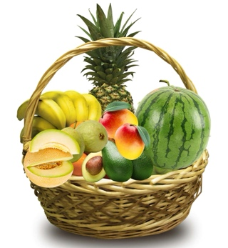 | Apples (4 units)
 | Plantain (1 kg)
 | Cassava (2 kg)
 | Kale (1 unit)
 | Eggs (12 eggs)
 | Sweet potato (1 kg)
 | Tomato (2 kg)
 | Parsley (1 bunch)
 | Carrot (1 pack)
 | Mango (3 units)
 | Coconut (2 units)
 | Passionfruit (5 units)
 | Garlic (0.5 kg)

BASKET 2:  (INSERT NAME OR CATEGORY. EXAMPLE: VEGETABLES AND EGGS)  PRICE: G$2.440 | Basket Description
Include a photo of the Basket or the products  Photo examples are on page 2  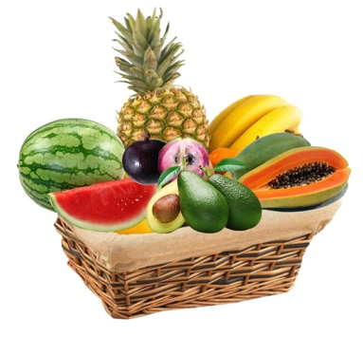  Reference photo ^ | Tomato (2 kg)
 | Avocado (2 units)
 | Papaya (4 units)
 | Pineapple (1 unit)
 | Eggs (12 eggs)
 | Bananas (5 units)
 | Onion (0.5 kg)
 | Watermelon (1 unit)
 | Coconut (2 units)
 | Cassava (1 kg)
 | Garlic (0.25 kg)
THANK YOU FOR SUPPORTING (NAME OF THE BUSINESS), A LOCAL BUSINESS!
PLEASE PLACE YOUR ORDER BY WHATSAPP MESSAGE TO THE NUMBER:
 099XXXXXX
ADDRESS ( INCLUDE BUSINESS ADDRESS)

RECOMMENDATIONS FOR BASKETS DELIVERY:
- The baskets described above examples only. Create your own baskets with products and quantities that are most requested by your customers.
- Add your own photographs, or the below photos to illustrate the baskets.
- Insert your business information, WhatsApp number and address.
- When sending the catalog, delete this second recommendation sheet; and send as PDF not in Word, since text can be modified in Word.
- To save in PDF, you only have to: 1) Save as 2) Instead of Word Document, Find the PDF option 3) Save
